✅ Black-Box Testing Overview
- Definition: Testing based on requirements and specifications without looking at internal code.
- Where it applies: All levels of development:
  - Unit testing
  - Integration testing
  - System testing
  - Acceptance testing
- Focus: Inputs and outputs.
- Common issues found: Missing functions, interface errors, performance problems.
- Pros: Helps testers choose efficient subsets of tests.
- Cons: Cannot guarantee full coverage of the system.

✅ Black-Box Testing Techniques
- Equivalence Class Testing (Partitioning)
  - Group similar input values into classes.
  - Test one value from each class.
  - Example:
    - Age-based bus fare:
      - 0–1 year → Free
      - 2–14 years → $10
      - 15–64 years → $15
      - 65+ years → $5
  - Limitations: Works best when inputs fall into ranges or sets.
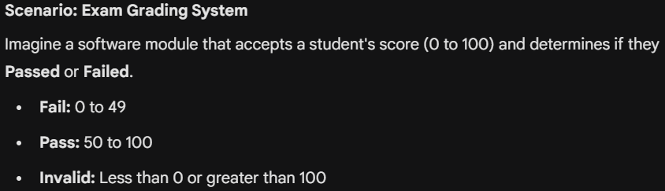
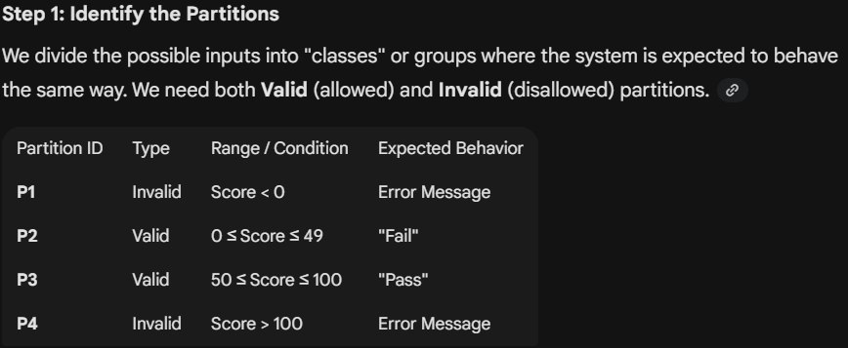
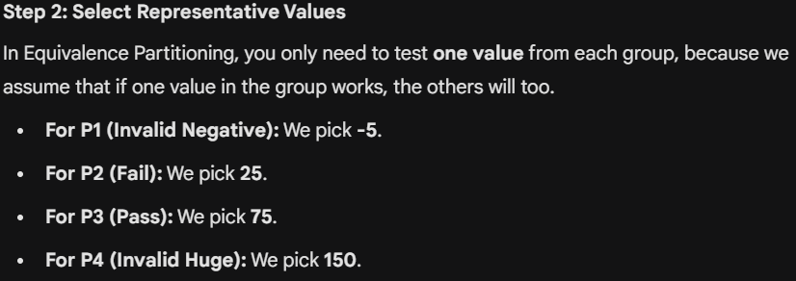
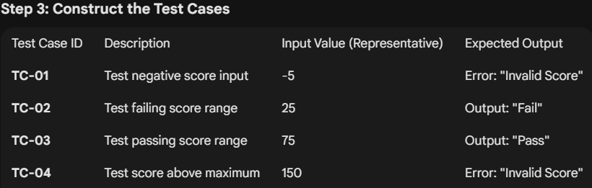
- Boundary Value Analysis
  - Most defects occur at boundaries.
  - Steps:
    - Identify equivalence classes.
    - Find boundaries.
    - Test values at, just below, and just above boundaries.
  - Example: Program accepts 3–6 inputs, each ≥ 10000.
  - Why is it important: Boundaries often hide defects in requirements or code.
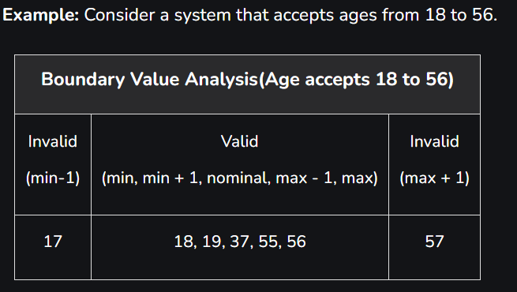
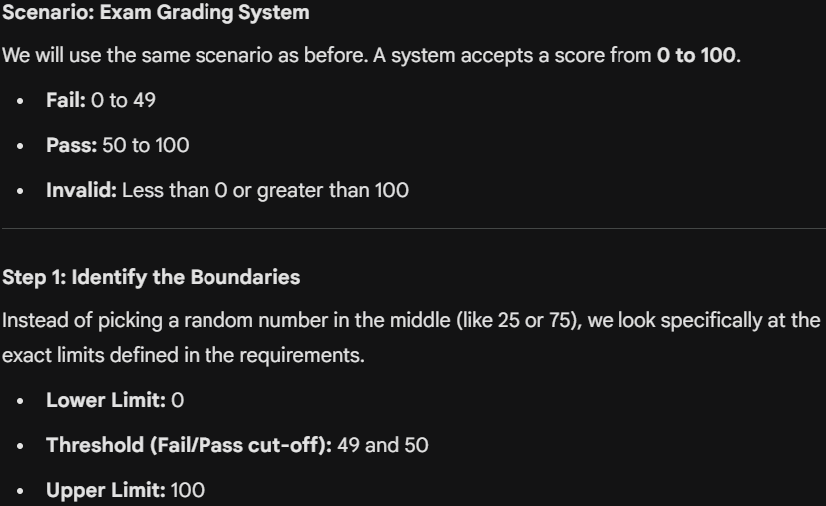
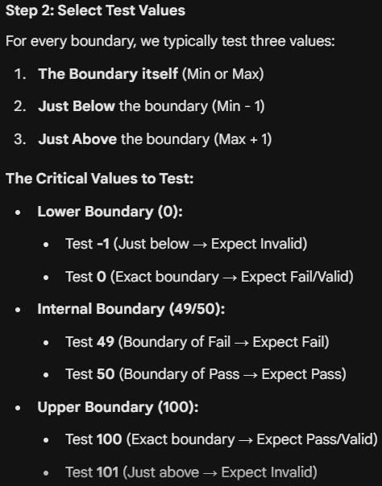
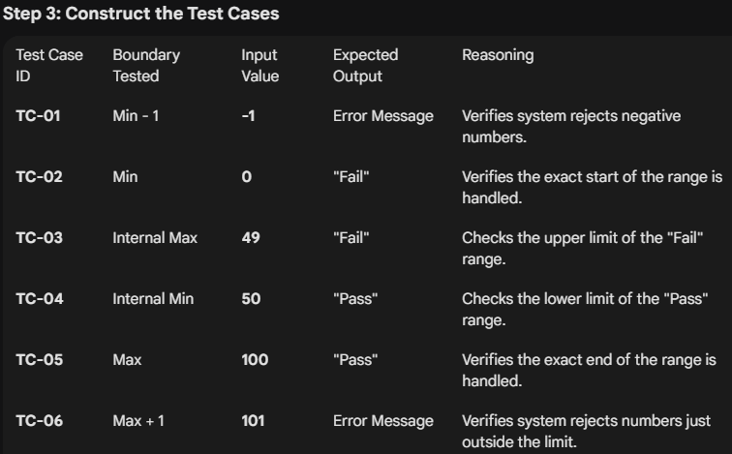
- Decision Table Testing
  - Represents complex business rules in a table.
  - Components:
    - Conditions: Factors affecting decisions.
    - Actions: What happens for each condition combination.
    - Rules: Define which actions apply for each condition set.
  - Example: Login system (email + password).
  - Advantages:
    - Covers all combinations.
    - Easy to understand.
    - Reduces rework.
  - Problem: Can become nondeterministic if rules conflict.
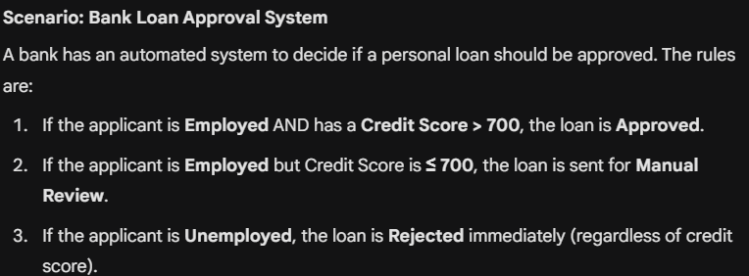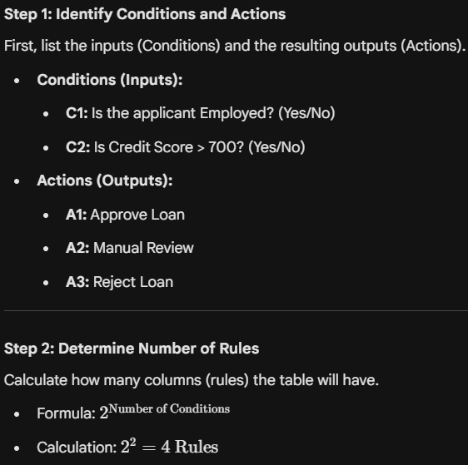
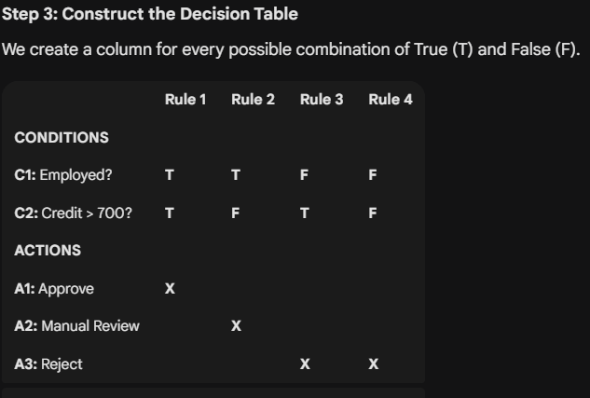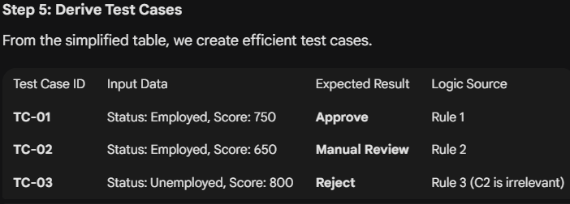
- State-Transition Testing
  - Used when system behavior depends on previous states.
  - State: A condition where the system waits for events.
  - Transition: Change from one state to another.
  - Event: Trigger for state change.
  - Action: Operation performed during transition.
  - Example:
    - Light switch: OFF → ON when switch ON.
    - Electronic clock: Display Time ↔ Display Date, Adjust modes.
  - Useful for systems with sequences or history.
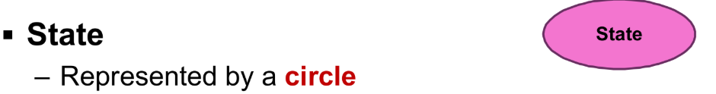
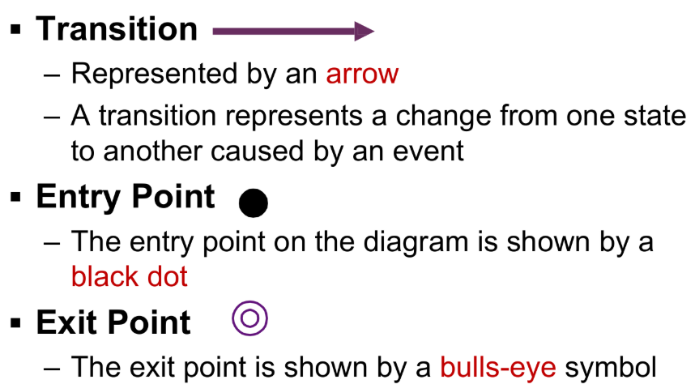
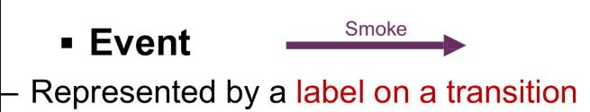
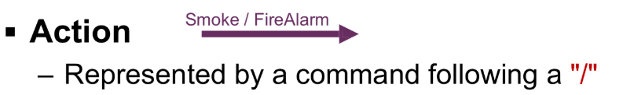
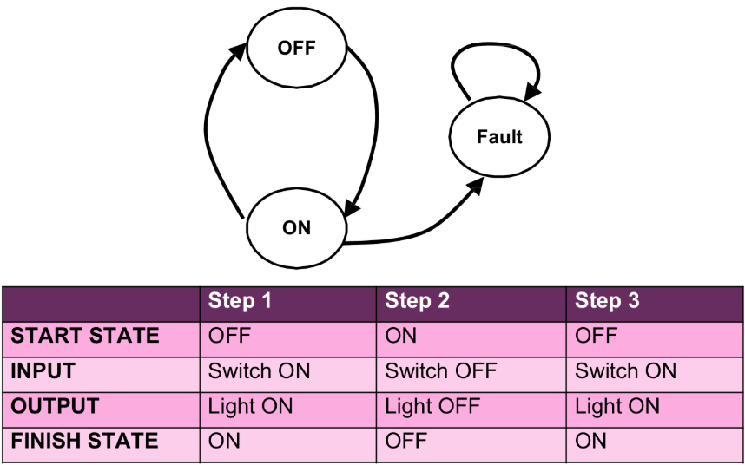
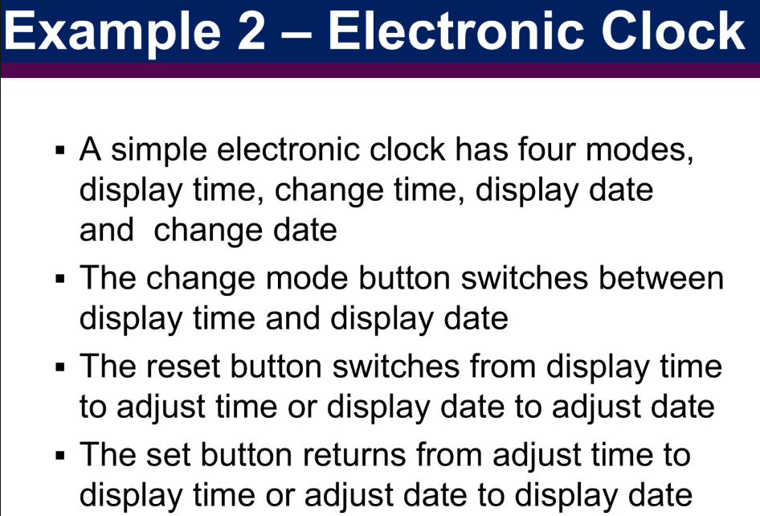
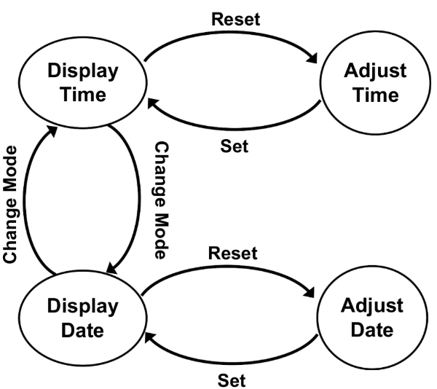
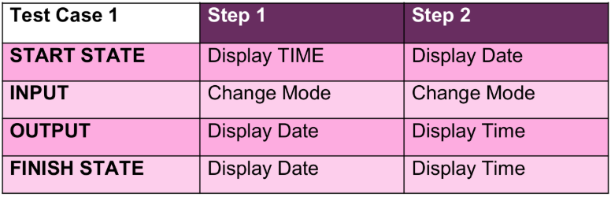
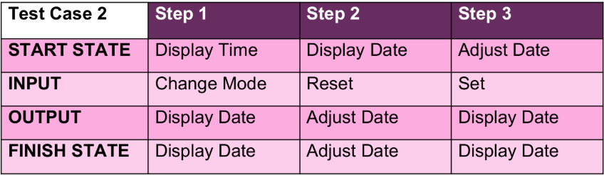
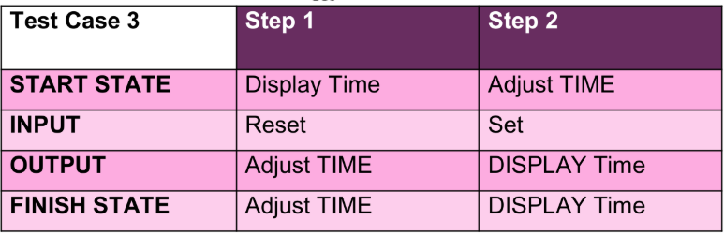

✅ Other Testing Types
- Stress Testing: Push system beyond normal limits to check robustness.
- Fuzzy Testing: Give random inputs to find unexpected failures.
- Progressive Testing: Test modules incrementally (Top-down, Bottom-up, Hybrid).
- Re-testing: Run failed tests again after fixing defects.

🔑 Key Takeaways
- Black-box testing focuses on what the system should do, not how it does it.
- Techniques like equivalence partitioning and boundary analysis make testing efficient.
- Decision tables and state-transition diagrams help handle complex logic.

